**5 Rust Projects to become a better developer**

[[](https://medium.com/@mohit-vaswani?source=post_page-----20c1c21f3311--------------------------------)](https://medium.com/@mohit-vaswani?source=post_page-----20c1c21f3311--------------------------------)

[Mohit](https://medium.com/@mohit-vaswani?source=post_page-----20c1c21f3311--------------------------------)

·

Follow

3 min read

·

3 days ago

7

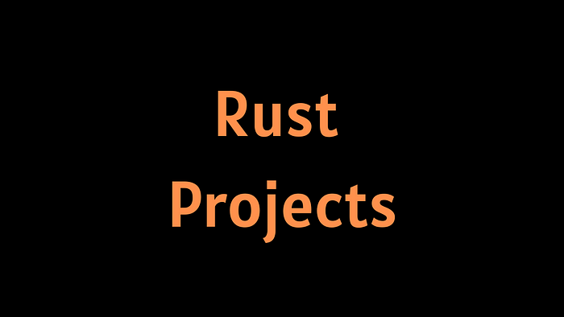

Rust is a safe, modern programming language developed by Mozilla. It’s designed for efficient, reliable software development, particularly in areas where low-level control over system resources is crucial. Rust features a unique ownership system that prevents common programming errors and a strong type system. Rust is easy to learn for developers familiar with C++. It’s popular in web development, embedded systems, and networking. The Rust community is active and supportive, with many libraries and frameworks available. To become a better Rust developer, check out these 5 Projects.

Additionally, I have included a link to [50 more rust projects](https://mohitvaswani21.gumroad.com/l/50-rust-projects) at the bottom of this article.

**1. Redox: A Rust Operating System**

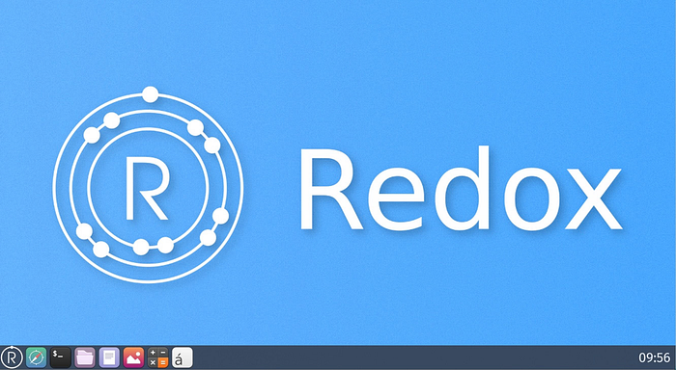

Redox is an operating system written in Rust, a language with focus on safety and high performance. Redox, following the microkernel design, aims to be secure, usable, and free. Redox is inspired by previous kernels and operating systems, such as SeL4, MINIX, Plan 9, and BSD.

[Github](https://github.com/redox-os/redox)

**2. Fyrox ~ 3D & 2D game engine written in Rust**

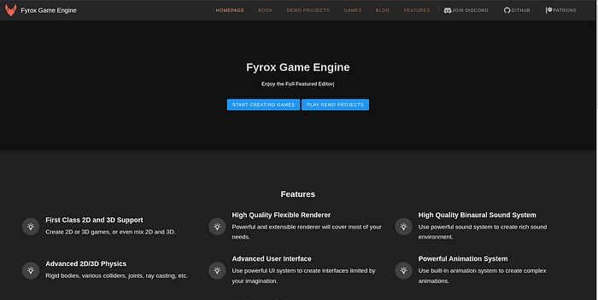

A feature-rich, production-ready, general-purpose 2D/3D game engine written in Rust with a scene editor. *Formerly known as rg3d*

[Github](https://github.com/FyroxEngine/Fyrox)

**3. Leptos: Build fast web applications with Rust**

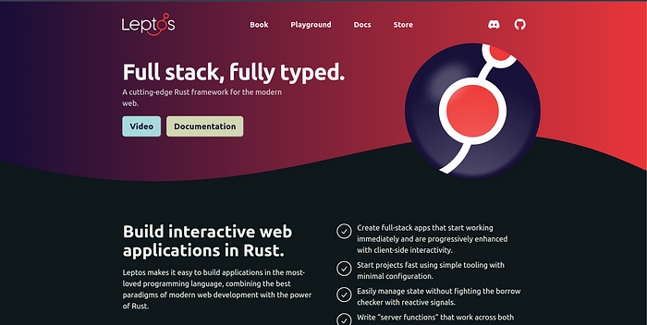

Leptos is a full-stack, isomorphic Rust web framework leveraging fine-grained reactivity to build declarative user interfaces.

[Github](https://leptos.dev/)

**4. Diesel ~ Safe, Extensible ORM and Query Builder For Rust**

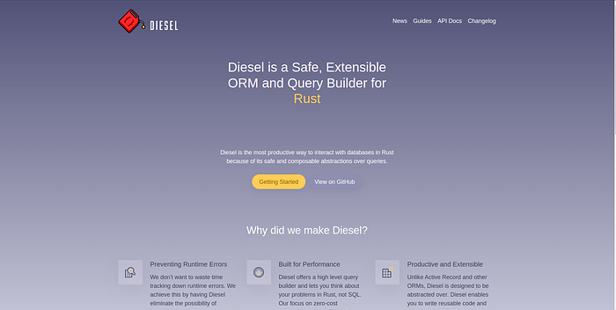

Diesel gets rid of the boilerplate for database interaction and eliminates runtime errors without sacrificing performance. It takes full advantage of Rust’s type system to create a low-overhead query builder that “feels like Rust.

[Github](https://github.com/diesel-rs/diesel)

**5. Tauri**

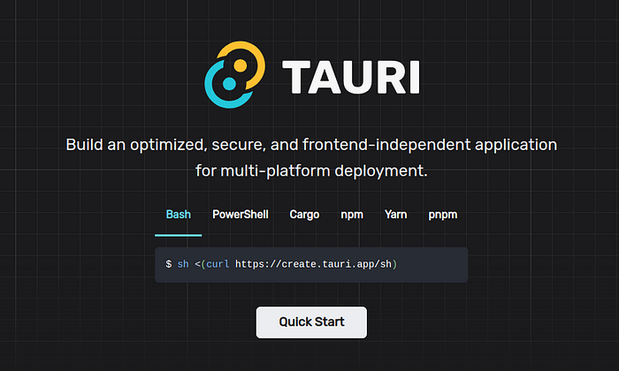

Build an optimized, secure, and frontend-independent application for multi-platform deployment.

[Github](https://github.com/tauri-apps/tauri)

**Bonus:**[**50+ More Projects ( Free for a Limited time )**](https://mohitvaswani21.gumroad.com/l/50-rust-projects)

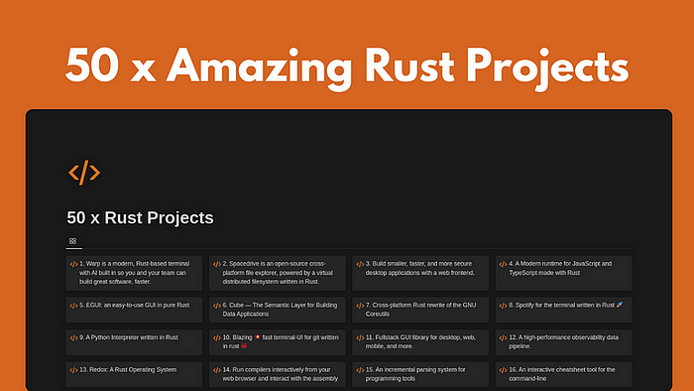

Thanks for reading. If you want more projects like this, please clap so that I can publish more.

[Rust](https://medium.com/tag/rust?source=post_page-----20c1c21f3311---------------rust-----------------)

[Backend](https://medium.com/tag/backend?source=post_page-----20c1c21f3311---------------backend-----------------)

[Programming](https://medium.com/tag/programming?source=post_page-----20c1c21f3311---------------programming-----------------)

[Coding](https://medium.com/tag/coding?source=post_page-----20c1c21f3311---------------coding-----------------)

[Development](https://medium.com/tag/development?source=post_page-----20c1c21f3311---------------development-----------------)